Escape Sequences

Definition:
# Source: AI Source: Provided by: [Data Path: Persons Table -> ID Column: 1, Name_En Column: Motasem Essam] -> From: [ChatGPT] on [1/26/2026]
An escape sequence is a special combination of characters starting with a backslash \ that represents characters or actions that are hard to type directly in a string.

Key Points
# Source: AI Source: Provided by: [Data Path: Persons Table -> ID Column: 1, Name_En Column: Motasem Essam] -> From: [ChatGPT] on [1/26/2026]
- Begins with backslash \ followed by a character.
- Used to represent:
  - Special characters (newline, tab, backslash)
  - Non-printable or control characters
- Commonly used in strings in programming languages like C, C++, Java, and Python.

Common Escape Sequences
# Source: AI Source: Provided by: [Data Path: Persons Table -> ID Column: 1, Name_En Column: Motasem Essam] -> From: [ChatGPT] on [1/26/2026]
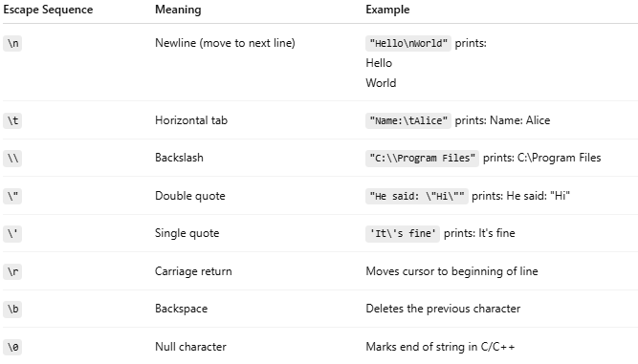
Escape Sequence | Meaning | Example
\n | Newline (move to next line) | "Hello\nWorld" prints: Hello World
\t | Horizontal tab | "Name:\tAlice" prints: Name: Alice
\\ | Backslash | "C:\\Program Files" prints: C:\Program Files
\" | Double quote | "He said: \"Hi\"" prints: He said: "Hi"
\' | Single quote | 'It\'s fine' prints: It's fine
\r | Carriage return | Moves cursor to beginning of line
\b | Backspace | Deletes the previous character
\0 | Null character | Marks end of string in C/C++

Examples
# Source: AI Source: Provided by: [Data Path: Persons Table -> ID Column: 1, Name_En Column: Motasem Essam] -> From: [ChatGPT] on [1/26/2026]
Python
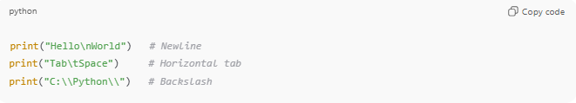
print("Hello\nWorld") # Newline
print("Tab\tSpace") # Horizontal tab
print("C:\\Python\\") # Backslash
C
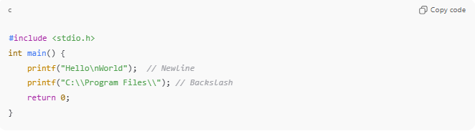
#include <stdio.h>
int main() {
printf("Hello\nWorld"); // Newline
printf("C:\\Program Files\\"); // Backslash
return 0;
}

Analogy
# Source: AI Source: Provided by: [Data Path: Persons Table -> ID Column: 1, Name_En Column: Motasem Essam] -> From: [ChatGPT] on [1/26/2026]
- Escape sequence → Special instruction in a text
- Example: \n → “Go to next line”
- Like a secret code in a letter telling the computer to do something special

✅ Summary
# Source: AI Source: Provided by: [Data Path: Persons Table -> ID Column: 1, Name_En Column: Motasem Essam] -> From: [ChatGPT] on [1/26/2026]
- Escape sequences = special characters starting with \
- Represent non-printable characters or actions in strings
- Examples: \n, \t, \\, \", \0

